State of California — Department of State Hospitals GAVIN NEWSOM, Governor


Department of State Hospitals - NAPA
2100 Napa-Vallejo Highway
Napa, California 94558
Phone: (707)253-5728 Fax: (707) 253-5299
Regarding Report Dated:

Honorable

RE:
Subject: Non-restorable patient at DSH-Napa from [COMMITTING COUNTY SUPERIOR COURT] County
SC:
NA:
MCD:

To the Presiding Judge:

The enclosed report on the above-named patient is submitted as required under Penal Code sections 1367 thru 1374 when the patient is unlikely to regain competency and approaching the maximum commitment date, which in this case expires on [Maximum Commitment Date].

Penal Code section 1370, subdivision (c)(1) states, “At the end of two years from the date of commitment or a period of commitment equal to the maximum term of imprisonment provided by law for the most serious offense charged in the information, indictment, or misdemeanor complaint, or the maximum term of imprisonment provided by law for a violation of probation or mandatory supervision, whichever is shorter, but no later than 90 days prior to the expiration of the defendant’s term of commitment, a defendant who has not recovered mental competence shall be returned to the committing court. The court shall notify the community program director or a designee of the return and of any resulting court orders.” (emphasis added).

The patient will reach their maximum term expiration date on the above listed maximum commitment date (MCD).

Sincerely,
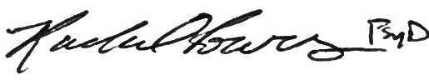
Rachel Powers, Psy.D. for
Seth Judd, D.O., or Designee
Medical Director
Wednesday, March 20, 2024

CC Defense Counsel, District Attorney, Public Guardian (if conservatorship investigation is recommended)

